**Project Name: Edgrow**

**Edgrow Mobile Testing**

**Category Menu:**

**1- Learn:**

My Learning: 🡨When I click on these options, it should navigate to a '404 – File Not Found' page.

(My-course html not a valid controller name)

**2- Categories:**

**Development:** 🡨When I click on these options, it should navigate to a '404 – File Not Found' page.

This massage should be display below the 404-File Not found 🡪 (Course-grid html is not valid controller name)

All these options come under Development 🡪

All Development

Web Development

Mobile app

Game Development

Databases

Programming languages

Software Testing

**Software Engineering** 🡨 when click that all options, these all options change the color only (black color convert to Blue)

**Business:** 🡨When I click on these options, it should navigate to a '404 – File Not Found' page.

This massage should be display below the 404-File Not found 🡪 (Course-grid html is not valid controller name)

All Business

Finance

Entrepreneurship

Strategy

Real State

Home Business

Communication

Industry, Other 🡨 when click that all options, these all options change the color only (black color convert to Blue)

**IT & Software** 🡨When I click on these options, it should navigate to a '404 – File Not Found' page.

This massage should be display below the 404-File Not found 🡪 (Course-grid html is not valid controller name

All IT & Software, IT Certification, Hardware, Network & Security, Operating system, Other 🡨 when click that all options, these all options change the color only (black color convert to Blue)

**Finance & Accounting**: 🡨 When I click on these options, it should navigate to a '404 – File Not Found' page.

This massage should be display below the 404-File Not found 🡪 (Course-grid html is not valid controller name

All Finance & Accounting, Accounting & Bookkeeping, Crypto currency & Block chain, Economics, Investing & Trading, other finance & Economics 🡨 when click that all options, these all options change the color only (black color convert to Blue)

**Design:** 🡨 When I click on these options, it should navigate to a '404 – File Not Found' page.

This massage should be display below the 404-File Not found 🡪 (Course-grid html is not valid controller name

All Design, Graphic design, web design, design tools, 3D & Animation, User experience, other

Personnel Development: 🡨 when click that all options, these all options change the color only (black color convert to Blue)

All Personnel Development, Personnel Transformation, productivity, leadership, personnel finance, career development, parenting & relationships 🡨When you click on those options, they should change color from black to blue

Marketing: 🡨When I click on these options, it should navigate to a '404 – File Not Found' page.

This massage should be display below the 404-File Not found 🡪 (Course-grid html is not valid controller name

All marketing, digital marketing, search engine optimization, social media marketing, branding, video & mobile marketing, affiliate marketing, growth hacking. 🡨When you click on those options, they should change color from black to blue

Health & fitness: 🡨When I click on these options, it should navigate to a '404 – File Not Found' page.

This massage should be display below the 404-File Not found 🡪 (Course-grid html is not valid controller name

All Health & fitness, fitness, sports, dieting, self-defense, mediation, mental health, yoga, 🡨When you click on those options, they should change color from black to blue

Photography: 🡨When I click on these options, it should navigate to a '404 – File Not Found' page.

This massage should be display below the 404-File Not found 🡪 (Course-grid html is not valid controller name

All photography, Digital photography, photography fundamental, commercial photography, 🡨When you click on those options, they should change color from black to blue

https://staging.edgrow.in/course-grid.html

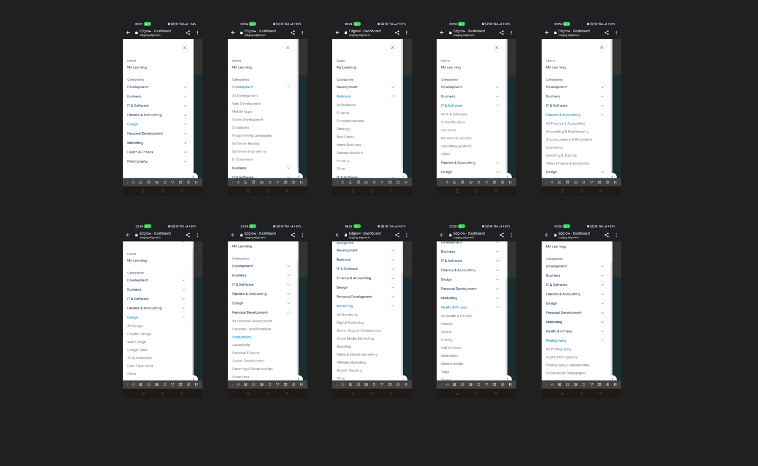

Please refer to the attached image for a clearer understanding of the defect.

This is all about “categories menu” in mobile testing.

**NOTE: The categories menu options and under the category there have been multiple options will be there but these all options aren’t showed (display) in web version.**

**Main Menu Option:**

Right side of edgrow mobile version ‘Three line’ is aligned when I clicked that main menu option have display.

Alert

1. Notifications 🡨When I click on these options, it should navigate to a '404 – File Not Found' (Dashboard html not a valid controller name)
2. Massages🡨When I click on these options, it should navigate to a '404 – File Not Found' (Dashboard html not a valid controller name)
3. Wishlist🡨When I click on these options, it should navigate to a '404 – File Not Found' (Dashboard html not a valid controller name)
4. My cart 🡨When I click on these options, it should navigate to a '404 – File Not Found' (Dashboard html not a valid controller name)

Account

Account setting 🡨When I click on these options, it should navigate to a '404 – File Not Found' (Dashboard html not a valid controller name)

Purchase History 🡨When I click on these options, it should navigate to a '404 – File Not Found' (Dashboard html not a valid controller name)

**Profile:**

Public profile🡨When I click on these options, it should navigate to a '404 – File Not Found' (Dashboard html not a valid controller name)

Edit profile🡨When I click on these options, it should navigate to a '404 – File Not Found' (Dashboard html not a valid controller name)

**Logout:** 🡨 when I click logout user has successfully logout from application.

More from Aduca

Aduca for Business🡨When I click on these options, it should navigate to a '404 – File Not Found' (Dashboard html not a valid controller name)

Get the App🡨When I click on these options, it should navigate to a '404 – File Not Found' (Dashboard html not a valid controller name)

Invite Friends 🡨When I click on these options, it should navigate to a '404 – File Not Found' (Dashboard html not a valid controller name)

https://staging.edgrow.in/dashboard.html

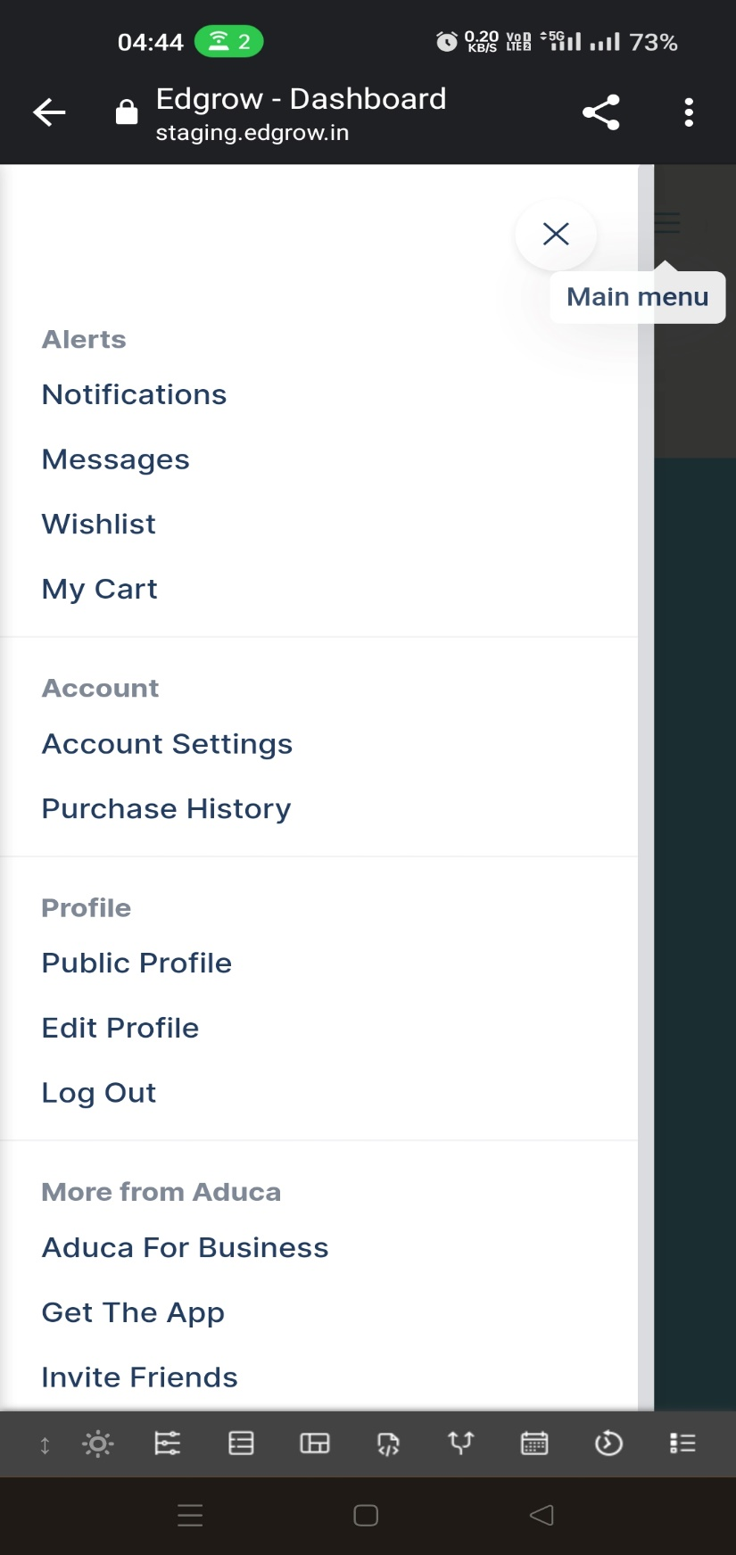

Please refer to the attached image for a clearer understanding of the defect.

**Main Menu**: 🡨 when I click to egdrow home another main menu options will be display on UI.

Home

Blogs

(Under the blogs these option🡪All blogs categories, coding, test, testing, technical test.)

Courses

Contact

Dashboard

Get A demo

**All these options should function as expected. When I click on any of these options, they should successfully navigate to different sections of Edgrow.**

When I enter the URl <https://staging.edgrow.in/> by using chrome in my mobile the edgrow website is successful open without any issue’s in my mobile.

left side is of website, edgrow logo is aligned it view same as well as desktop, right side ‘Got to card and its logo and “Three lines is top at the right side.

When I click ‘three lines’

Home

Blogs

Courses

Contact

Login Get A Demo

All these functions are working fine it worked as well as desktop while user clicking these options, they should successfully redirect to different page.

When I logged in Edgrow website in mobile, I successfully logged in my account edgrow these options should be display ‘courses’ Learn with our expert and all courses

**Wishlist:**

When selecting any course and clicking the 'heart icon' or adding it to the Wishlist, the course should be successfully added to the Wishlist. or if I choose to remove the course from the Wishlist by clicking on it, it should be successfully removed from the Wishlist.

**Got to Cart:**

When selecting any course and clicking the got to cart button the course should be successfully added to the got to cart.

If user want to purchase the course which they added in them add to cart the user click buy this course and click on razor pay payment option the user should navigate to payment page successfully.

**Coupon code:**

The coupon code is successfully applied to the course, and the user should receive the discount with the coupon code.

The coupon code can be applied only once. The user should not be able to use it again for buying a course. For example, if a user wants to buy the Java course and applies a coupon code during the purchase, they should not be able to reuse the coupon for the same Java course. If the user attempts to apply the coupon again, the error message 'The given coupon has reached its maximum limit' should be displayed accurately.

**Course Purchase:**

* Click on all courses page, all 14 courses successfully displayed.
* When I select anyone the course successful added in got to cart.
* Course price + 18% GST properly displayed.
* Click on razor pay payment option it courses price+18% user should successfully land in payment section.
* If user has purchase 1 or 2 courses simultaneous, they should buy & user should able to do the payment of both courses without any issue.

All these functionalities are working fine I won’t seem any bug when trying to select a course, purchase it will successfully go to got to cart, coupon code is successfully applied for course purchase, user should purchase a course with easy manner.

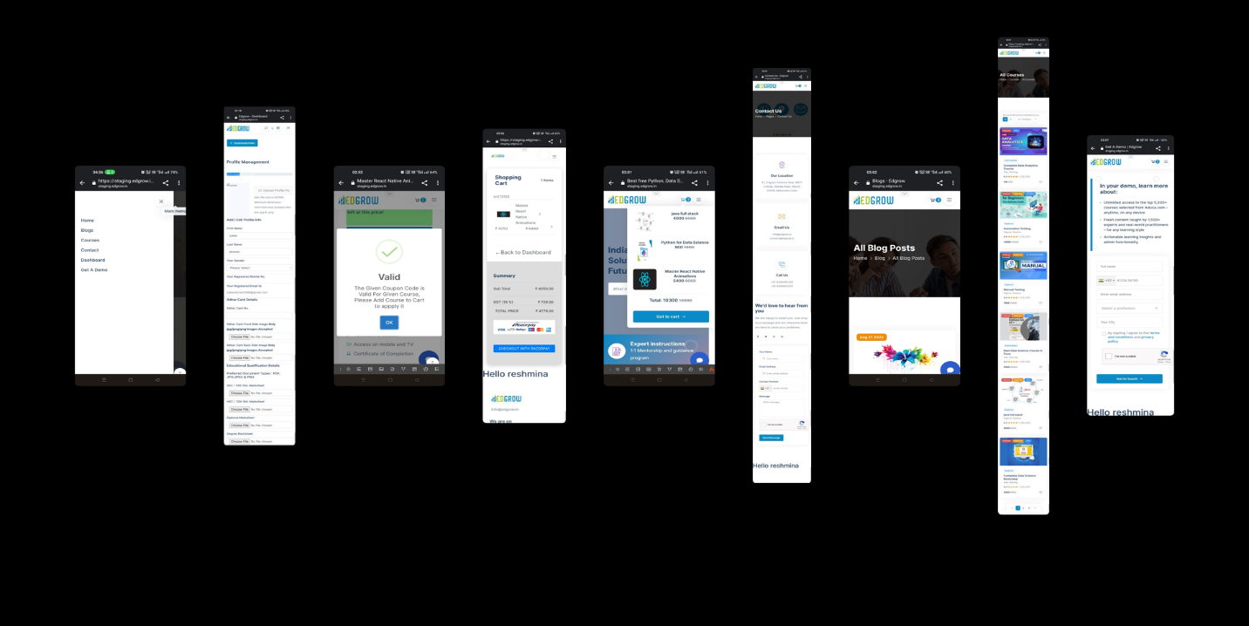

Please refer to the attached image for a clearer understanding of the defect.

**Add New Course: 🡪** User should not able to purchase newly added course error massage should be display in the UI. (User should not able to purchase newly added course in the (Oops! Something went wrong. Invalid amount. Amount should be passed in integer paise. The minimum value is 100 paise, i.e., ₹1).

**Pricing:**

* Course price should be accurately displaying on UI.
* Accurate 18% GST should be charged.
* **Special discount of course should not reflect on the course price.**
* Coupon code discount is applying successfully to the users.
* UPI payment should be successful accepted.
* Credit card payment should successfully accept.
* Net Banking payment should be successfully accepted.
* User should able to use the Phonepe, Paytm, Mobikwik Wallets.

**Calculation of pricing:**

* **The calculation of the course is not working properly.**
* **Extra amount should be charged by razor pay section**
* **User should purchase the course due to calculation errors.**

**Dashboard:**

When I click dashboard these options successfully display.

* All courses 🡪 14 courses successfully display
* **Dashboard 🡪 dashboard Nav, upload image, Howdy, Zaker Ahmed, enroll courses 11, Active courses 5, completed courses 6 but if I click these options it hasn’t go anywhere, I observed that is bug.**
* My course 🡪 when click this url <https://staging.edgrow.in/student/my-courses> Oops! Nothing in your course list browser
* My Wishlist🡪 when I click this url <https://staging.edgrow.in/student/wishlist> Oops! Nothing in your course list browser
* My profile 🡪 <https://staging.edgrow.in/student/my-profile> all my details is display successful
* Exam 🡪 <https://staging.edgrow.in/student/exam> **when I click it hasn’t gone anywhere “white screen (blank page) display.**
* Exercises 🡪 <https://staging.edgrow.in/student/exercises> **when I click it shows** **Error Exception, Undefined variable: exercises**
* Payment history 🡪 successfully course purchase details
* Logout 🡪 successfully logout from application.

**India's #1 Stop Solution to learn   
Future Technologies**

Top of Form

 🡨 **When attempting to search using the search bar, the page only refreshes without displaying any search results. It does not navigate to the desired search result. For Example, if I search for 'Java course,' it should display the Java course, but the search bar isn't functioning as expected. This behavior indicates a bug.**

Bottom of Form

#### Expert instructions Jobs in 100+ Top Companies

1:1 Mentorship and guidance program learn practically to land jobs faster

#### Lifetime free access

Learn on your schedule

## Why Choose Edgrow?

##### Learn from scratch Showcase your skills and build Projects

Edgrow Helps you to Learn Data Science in local language. Don't just watch videos build projects with us.

##### Boost your confidence by mock interviews Certification and Internships

1:1 Mentorship to land a decent job. Join us and remove your fresher tag.

When attempting to Why choose Edgrow and other below options like, learn from scratch, showcase your skills and build Projects, showcase your skills and build Projects, Certification and Internships, **it does go any page so these behaviors is indicating here is bug.**

**All Courses:**

When I clicking the all courses section total 14 courses should be display, and if select any one course so all the detail of the course is successfully display such as

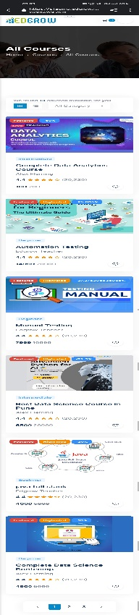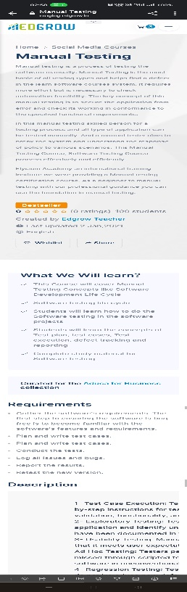

The course page is functioning as expected. Users can view all courses upon selecting the course page. If a user chooses a specific course, the Edgrow website should successfully display all relevant information.

**Trending course:**

Newly added course is landing on the top of courses and other courses are displays successfully in the UI. In trending section everything working as expected.

**Companies Where Our Students Are Working:**

All the names and logos of the companies should be displayed successfully. A total of 9 companies should be displayed in a single line, each appearing sequentially in the UI.

**Student’s feedback:**

All the student feedback with student ‘photo’ should be displayed successfully.

**Explored all:** 🡪 when I click this button it should not go anywhere

**Sign up for our newsletter:**

**Subscribe Button:** 🡪 When I verify the subscribe button, it should not work. If I enter an email address in the text box and click the subscribe button, it should not navigate to another page or perform any action. The user should not be able to subscribe successfully. I noticed this behavior in both the newsletter section and the subscribe button section.

**Conclusion:**

As per the requirements, I thoroughly tested the entire Edgrow website on mobile. When attempting to open it on a mobile device, the website successfully redirects to the homepage. On the left side of the homepage, the Edgrow name in capital letters is aligned, while on the right side, 'Go to Cart' and the 'three lines' are also aligned. Clicking the three lines icon reveals a dropdown menu with 6 options.

The mobile version of the Edgrow homepage closely resembles the desktop version, though some options are not visible on mobile. Upon clicking the 'Login' option, the website successfully navigates to the login page. Logging in with Google ('Continue with Gmail') works seamlessly.

After a successful login, a 'Dashboard' button is displayed on the left side below the website heading. On the right side, a search bar, 'b' icon, category menu (box), and three lines are placed. Clicking the three lines icon reveals 10 options. All options work except for 'Exam & Exercises,' which do not navigate to the intended target page.

When attempting to use the search bar and entering a search query, the expected action is to display 'Action Info Wishlist messages. However, it requests to log in as a student first to add a course to the wishlist, creating uncertainty about the search bar's behavior. Please verify if this is a bug and resolve it promptly.

Upon clicking the box (category menu) and selecting 'Learn' and 'Categories,' some options display a '404 - File Not Found' error. Similarly, clicking 'Main Menu' (three lines) displays multiple options that, upon clicking, redirect to '404 - File Not Found.'

When clicking on the 'Edgrow' heading of the website, successful redirection to the homepage is expected. The layout includes the Edgrow name in capital letters on the left and 'Go to Cart' and 'three lines' on the right. Clicking the three lines icon reveals 6 options, each successfully navigating to the intended target page.

After a successful login, different options are displayed on the page. Initially, these options do not work, leading to a redirection to the 404 page. Upon refreshing the page, a different page is displayed, and all options on this page work as expected.

**Note: All bugs are highlighted in red for easy identification and understanding.**

Regards

Shaikh Zaker

Software Test Engineer

Codem Power Solution Pvt Ltd